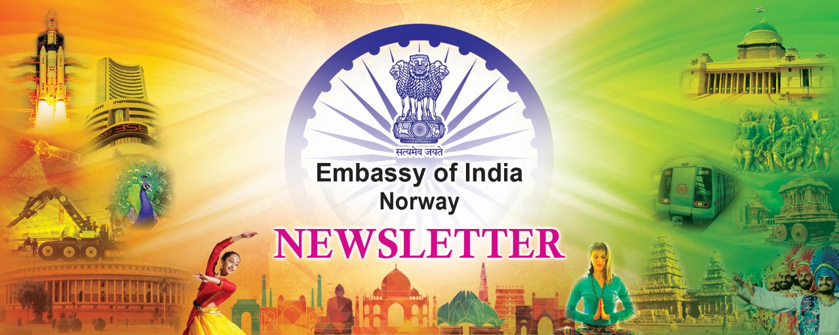

India

PM Modi attends G20 Summit:
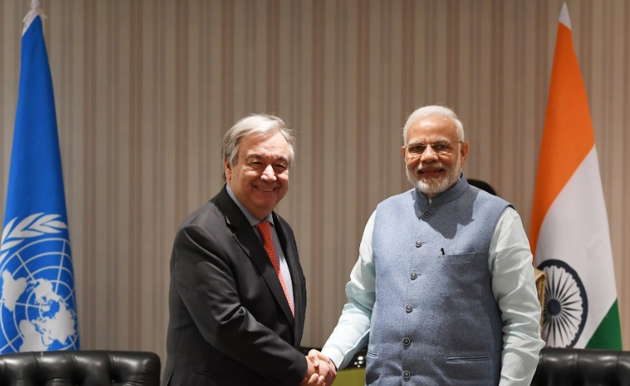

PM Modi met UN Secretary General Antonio Guterres at the sidelines of the G20 Summit

Prime Minister Narendra Modi attended the 13th G20 Summit which was hosted by Argentina in Buenos Aires under the theme “Building Consensus for Fair and Sustainable Development” from 29 November to 1 December. PM Modi stated that India’s contribution to global economic growth and prosperity underlined its commitment to fair and sustainable development, and highlighted that through its ten years of existence, G-20 had strived to promote stable and sustainable growth. PM Modi also emphasized that this objective was of particular significance for developing countries and emerging economies such as India, which was today

the fastest growing large economy in the world.

Winter Session of Parliament begins:
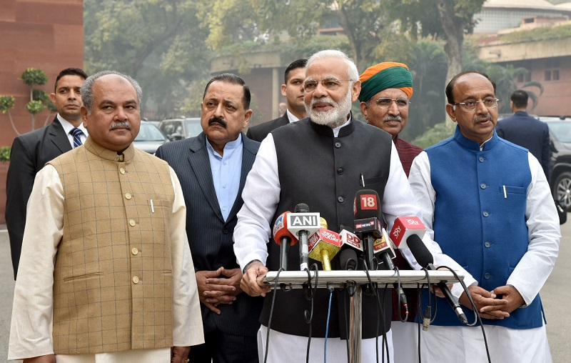

PM Modi’s statement to the media at the start of the Winter Session of Parliament

In his statement to the media on 11 December at the commencement of the Winter Session of Parliament, PM Modi stated that the Winter Session was important as key legislative bills were pending which were in the interest of the people of India. He expressed hope that the proceedings would be smooth, and highlighted his belief in that all the political parties which would be facing the test in May would make the most out of this session, keeping in mind the welfare of the public and not for the interests of their respective parties.

Boost to India’s Space Programme: On 28 December, the Union Cabinet chaired by Prime Minister Shri Narendra Modi approved the Gaganyaan Programme and announced an allocation of INR 100 billion (approx. USD 1.43 billion) to the programme. The objective was to demonstrate Indian Human Spaceflight capability to low earth orbit for a mission duration ranging from one orbital period to a maximum of seven days. Two unmanned flights and one manned flight would be undertaken as part of Gaganyaan Programme, and a human rated GSLV Mk-lll launch vehicle would be used to carry the orbital module which would have necessary provisions for sustaining a 3-member crew for the duration of the mission. The necessary infrastructure for crew training, realization of flight systems and ground infrastructure would be established to support the Gaganyaan Programme. The Indian Space Research Organisation would collaborate extensively with National agencies, laboratories, academia and industry to accomplish the Gaganyaan Programme objectives.

Indian States / Festivals

Nagaland:
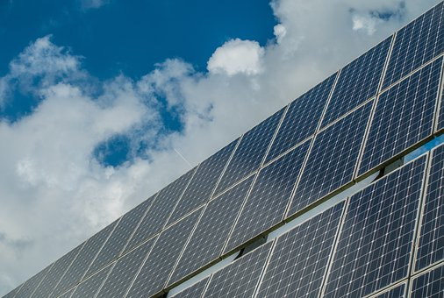

Nagaland aims to develop 50MW of roof top solar power Photo: Nagaland Industry News

Nagaland is a state in Northeast India which borders Myanmar to the east, the state of Manipur to the south, the state of Assam to the west and Arunachal Pradesh and Assam to the north. Nagaland’s economy ranks 29th among India’s 33 states and union territories with GDP of approx. USD 3.2 billion, and it is a fast growing state economy with GDP growth of 10%. Agriculture is a main sector of Nagaland’s economy, and the state government is in the process of drawing up a new industrial policy to increase business opportunities and to help promote Micro and Small Enterprises with special focus on start-ups. The industrial policy would focus on empowering the local entrepreneurs besides establishing manufacturing hubs and economic zones, and the state aims to facilitate investment in the hydro power sector. The state is also rich in minerals like coal, nickel, cobalt, magnetite, marble, petroleum, natural gas, decorative stones and limestone. The mineral resources have led to establishment of many important industries such as extraction of petroleum, natural gas, molybdenum, copper, gold, silver metals and limestone industries which have added to the state’s economic strength. Other important industries include bamboo related industries like paper mills and plywood factories, cottage industries like spinning, weaving and cane works, sugar mills and oil factories.
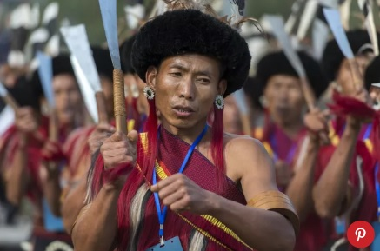

Hornbill Festival, Nagaland - Photo: Tripsavvy.com
Moreover, Nagaland has many places of tourist interests which attract visitors throughout the year. One of the notable tourist destinations is Japfu Peak at 3084 metres above sea level which offers wonderful opportunities to enjoy the natural splendour of the region. Other notable tourist destinations are the World War II Cemetery of Nagaland and Kohima Village which offer a unique scope to experience the rich traditional legacy of Nagaland. Also, the Hornbill Festival is held in Kisama Heritage Village near Kohima from 1 to 10 December every year to celebrate the indigenous warrior tribes of the region. The festival features traditional arts, dances, folk songs, games, music and local handicrafts.

Celebration of Chhau Jhumur Utsav:
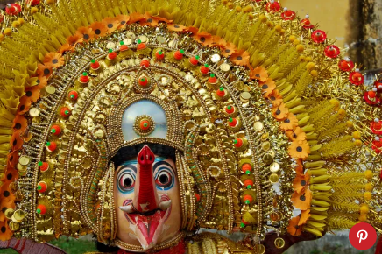

Chhau Jhumur Utsav
Photo: Tripsavvy.com

The Chhau Jhumur Utsav was held from 22 to 28 December in the Purulia district in West Bengal to celebrate the ancient regional chhau folk dance of eastern India. During the festival, nearly 2,000 artists were engaged in performing this folk art tradition. The chhau dance is characterized by acrobatic twists and turns, and incorporates stories based on mythological tales to promote moral and ethical values. The dancers also wear unique masks which are made prior to the festival. The Purulia district has been developed as a rural crafts hub by the government of West Bengal and UNESCO.

International commercial & business activities in India

Ease of Doing Business Review:
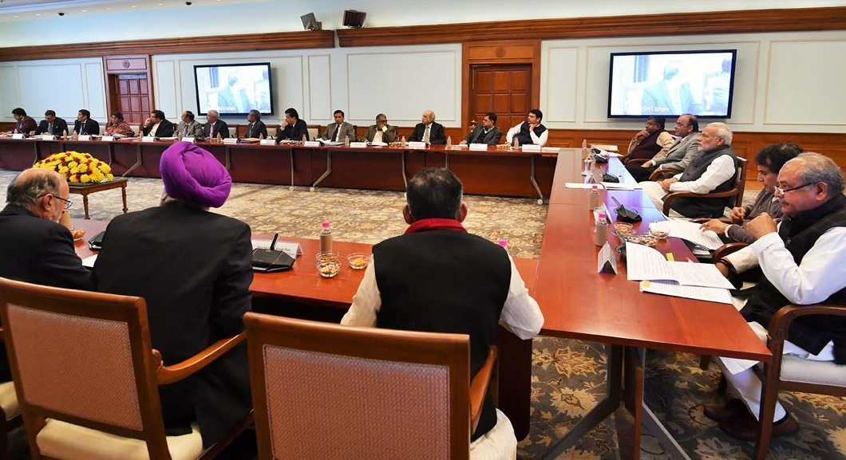

PM Modi at Ease of Doing Business Review

On 13 December, PM Narendra Modi chaired a high-level meeting to review progress with regard to Ease of Doing Business. The Prime Minister was briefed on progress being made on various parameters related to Ease of Doing Business, and issues such as construction permits, enforcement of contracts, registering property, starting a business, getting electricity, getting credit and resolving insolvency were discussed. PM Modi stated that there was tremendous global interest about the rise in India’s Doing Business rankings, and stressed the need to improve last mile delivery and streamline procedures which would improve the Doing Business rankings and also increase the Ease of Living for small businesses and the common man.

India-Norway

Norwegian government presents new India strategy paper: On 14 December, FM Ine Eriksen Søreide presented the Norwegian government’s new strategy for cooperation with India titled “Norway – India 2030”. The strategy contained six objectives for Norway’s cooperation with India in the period until 2030 including (i) increasing cooperation to strengthen multilateral cooperation, the international trading system and the international legal order, (ii) increasing Norwegian companies’ market share in India’s ocean-based sector, (iii) supporting sustainable use of marine resources in India and efforts to reduce marine litter, (iv) increasing Norwegian companies’ market share in India’s energy sector, (v) supporting India’s efforts to reduce emissions and meet its obligations under the Paris Agreement, and (vi) being an attractive partner for India in the areas of research, higher education and global health. H.E. Mr. Krishan Kumar, Ambassador of India to Norway was invited as Guest of Honour. Ambassador in his speech highlighted areas of potential growth between the two countries underlining India’s Skill India programme, Make in India programme, sectoral developments, global health, the pharmaceutical industry, global terrorism and people to people relations. Ambassador took an opportunity to raise issues relating to Indian diaspora living in Norway and issues of delayed/denial visas etc.

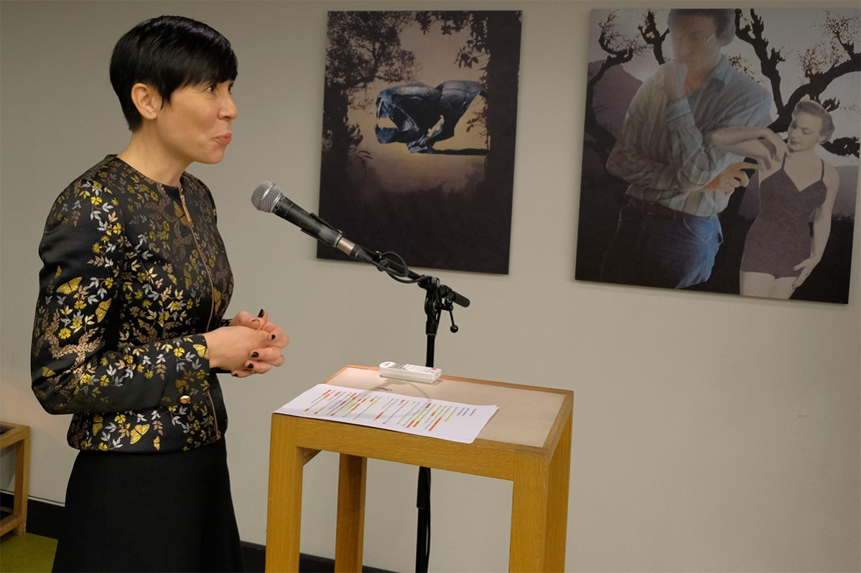

FM Søreide presented the India strategy
Photo: Jan Speed/Bistandsaktuelt.no

International Development Minister Astrup in New Delhi: On 12 December, International Development Minister Nikolai Astrup attended the Partner Forum 2018 of the Partnership for Maternal, Newborn and Child Health (PMNCH) which was hosted by the Government of India in New Delhi. The Forum brought together 1,200 partners dedicated to the Every Woman Every Child (EWEC) movement. The purpose of the Forum was to create greater political momentum on the issue of maternal, newborn and child health, share best practices and knowledge to innovate and improve implementation strategies, and to improve cross-sectoral collaboration through knowledge exchange and joint advocacy strategies. A Keynote address was delivered by PM Narendra Modi. PM Modi also met Mr. Astrup at the start of the Partner Forum 2018.
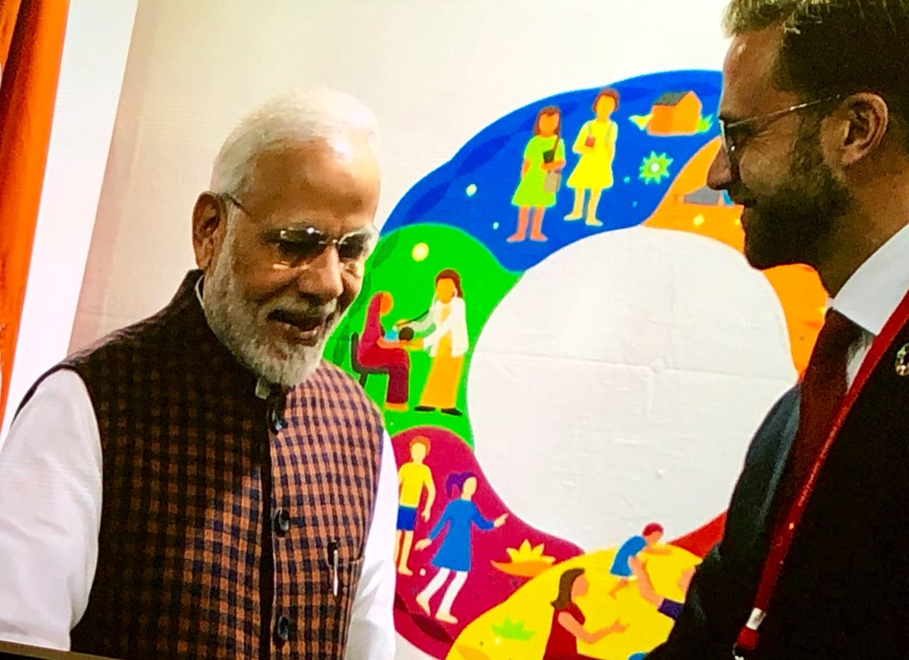

PM Modi met International Development Minister Astrup at the Partner Forum 2018.
Photo:Royal Norwegian Embassy in New Delhi

Indian Community

Celebration of the Republic Day of India: The Embassy of India will be organizing a Flag Hoisting Ceremony on the occasion of the 70th Republic Day of India. All Indian Nationals, PIOs and friends of India are cordially invited to attend the event on Saturday, 26th January, 2019 at 10.00 a.m. at the Embassy premises, Niels Juels Gate 30, 0244 Oslo.

